Linear Gap

Definition
# Source: AI Source: Provided by: [Data Path: Persons Table -> ID Column: 1, Name_En Column: Motasem Essam] -> From: [ChatGPT] on [7/25/2026]
A Linear Gap is the separation between two geometric objects measured along a common line or linear direction.
It represents the length of the empty interval between two separated positions, points, line segments, or other objects whose relevant boundaries lie on the same line.
For two separated points $A$and $B$on a line:
$$\boxed{g=AB}$$
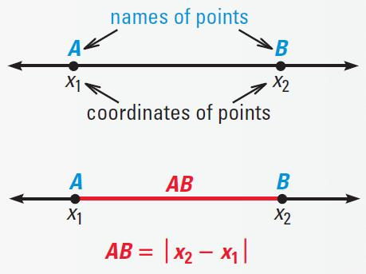
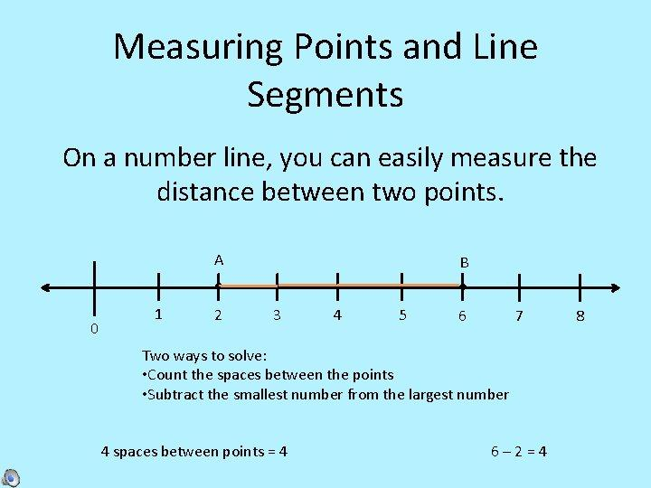
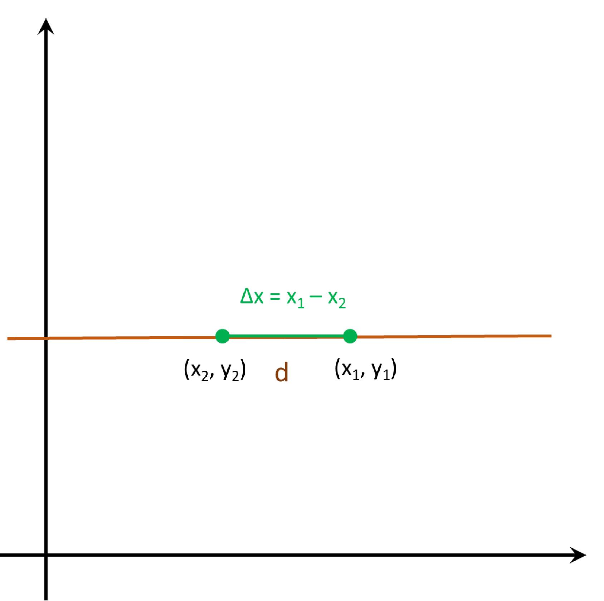

Purpose
# Source: AI Source: Provided by: [Data Path: Persons Table -> ID Column: 1, Name_En Column: Motasem Essam] -> From: [ChatGPT] on [7/25/2026]
A Linear Gap is used to:
- Describe separation along a straight line.
- Measure spacing between objects.
- Determine the distance between adjacent linear boundaries.
- Describe empty intervals between line segments.
- Analyze clearances and spacing in geometric constructions.

Fundamental Concept
# Source: AI Source: Provided by: [Data Path: Persons Table -> ID Column: 1, Name_En Column: Motasem Essam] -> From: [ChatGPT] on [7/25/2026]
Consider two separated line segments:
A────────B C────────D
│← Gap →│
The gap is the interval between the nearest endpoints $B$and $C$.
If $B$and $C$lie on the same line:
$$\boxed{g=BC}$$
Thus, a Linear Gap is essentially a linear distance representing an empty interval between two objects.

Mathematical Representation

Points on a Number Line
# Source: AI Source: Provided by: [Data Path: Persons Table -> ID Column: 1, Name_En Column: Motasem Essam] -> From: [ChatGPT] on [7/25/2026]
For two points with coordinates $x_{1}$and $x_{2}$:
$$\boxed{g=∣x_{2}-x_{1}∣}$$
Example:
$$x_{1}=4, x_{2}=11 \\ g=∣11-4∣=7$$
Therefore:
$$\boxed{g=7}$$

2. Two Collinear Line Segments
# Source: AI Source: Provided by: [Data Path: Persons Table -> ID Column: 1, Name_En Column: Motasem Essam] -> From: [ChatGPT] on [7/25/2026]
Suppose:
$$AB=\left[2 , 6\right]$$
and
$$CD=\left[10 , 15\right]$$
The nearest endpoints are $B=6$and $C=10$.
Therefore:
$$g=10-6 \\ \boxed{g=4}$$
The linear gap is the interval:
$$\boxed{\left(6 , 10\right)}$$
and its length is $4$.

Types of Linear Gap

1. Point-to-Point Linear Gap
# Source: AI Source: Provided by: [Data Path: Persons Table -> ID Column: 1, Name_En Column: Motasem Essam] -> From: [ChatGPT] on [7/25/2026]
The separation between two points on the same line.
$$\boxed{g=∣x_{2}-x_{1}∣}$$
A •────────────• B
Gap

2. Segment-to-Segment Linear Gap
# Source: AI Source: Provided by: [Data Path: Persons Table -> ID Column: 1, Name_En Column: Motasem Essam] -> From: [ChatGPT] on [7/25/2026]
The separation between two non-overlapping collinear line segments.
─────── ───────
← Gap →

3. Endpoint-to-Endpoint Gap
# Source: AI Source: Provided by: [Data Path: Persons Table -> ID Column: 1, Name_En Column: Motasem Essam] -> From: [ChatGPT] on [7/25/2026]
The gap specifically measured between two nearest endpoints.
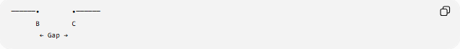
──────• •──────
B C
← Gap →
$$\boxed{g=BC}$$

4. Boundary-to-Boundary Linear Gap
# Source: AI Source: Provided by: [Data Path: Persons Table -> ID Column: 1, Name_En Column: Motasem Essam] -> From: [ChatGPT] on [7/25/2026]
The linear separation between two boundaries measured in a specified direction.
This is common when describing spacing or clearance between geometric regions.

Zero Linear Gap
# Source: AI Source: Provided by: [Data Path: Persons Table -> ID Column: 1, Name_En Column: Motasem Essam] -> From: [ChatGPT] on [7/25/2026]
If two objects meet at their nearest boundaries:
$$\boxed{g=0}$$
For example:
───────•───────
B=C
The objects are touching, rather than separated by a positive gap.

Positive Linear Gap
# Source: AI Source: Provided by: [Data Path: Persons Table -> ID Column: 1, Name_En Column: Motasem Essam] -> From: [ChatGPT] on [7/25/2026]
If:
$$\boxed{g>0}$$
the objects are separated by a positive interval.
─────── ───────
← g →

Linear Gap vs. Point Gap
# Source: AI Source: Provided by: [Data Path: Persons Table -> ID Column: 1, Name_En Column: Motasem Essam] -> From: [ChatGPT] on [7/25/2026]
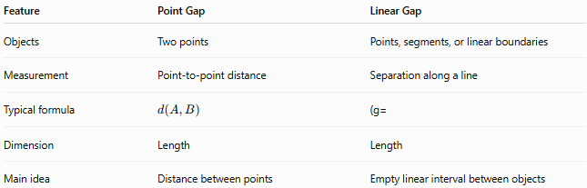
Feature | Point Gap | Linear Gap
Objects | Two points | Points, segments, or linear boundaries
Measurement | Point-to-point distance | Separation along a line
Typical formula | $$d\left(A , B\right)$$ | (g=
Dimension | Length | Length
Main idea | Distance between points | Empty linear interval between objects
A Point Gap can therefore be viewed as a special case of a Linear Gap when the two objects are points lying on the same line.

Linear Gap vs. Distance
# Source: AI Source: Provided by: [Data Path: Persons Table -> ID Column: 1, Name_En Column: Motasem Essam] -> From: [ChatGPT] on [7/25/2026]
The terms are related but not identical.
- Distance is the formal numerical measure of separation.
- Linear Gap emphasizes the empty linear space or interval between objects.
For example:
Object A Gap Object B
███████ 5 cm ███████
Here:
$$\boxed{\text{Gap length}=5\text{ cm}}$$
and the corresponding distance between the nearest boundaries is $5\text{ cm}$.

Example
# Source: AI Source: Provided by: [Data Path: Persons Table -> ID Column: 1, Name_En Column: Motasem Essam] -> From: [ChatGPT] on [7/25/2026]
Two line segments lie on the $x$-axis:
$$AB:\left[1 , 5\right]$$
and
$$CD:\left[12 , 18\right]$$
The nearest endpoints are $B=5$and $C=12$.
Therefore:
$$g=∣12-5∣ \\ \boxed{g=7}$$
So the two segments have a linear gap of 7 units.

Relationship with Other Gaps
# Source: AI Source: Provided by: [Data Path: Persons Table -> ID Column: 1, Name_En Column: Motasem Essam] -> From: [ChatGPT] on [7/25/2026]
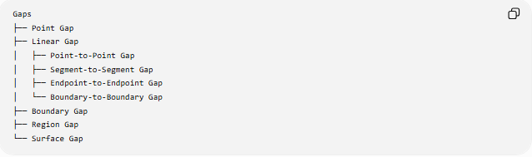
Gaps
├── Point Gap
├── Linear Gap
│ ├── Point-to-Point Gap
│ ├── Segment-to-Segment Gap
│ ├── Endpoint-to-Endpoint Gap
│ └── Boundary-to-Boundary Gap
├── Boundary Gap
├── Region Gap
└── Surface Gap

Real-World Applications
# Source: AI Source: Provided by: [Data Path: Persons Table -> ID Column: 1, Name_En Column: Motasem Essam] -> From: [ChatGPT] on [7/25/2026]
Linear gaps appear in:
- Construction — spacing between structural components.
- Engineering — mechanical clearances.
- Manufacturing — spacing between parts.
- Roads — distance between vehicles.
- Architecture — spacing between walls or structures.
- Surveying — separation between measurement points.
- CAD — clearance between linear components.

Key Points
# Source: AI Source: Provided by: [Data Path: Persons Table -> ID Column: 1, Name_En Column: Motasem Essam] -> From: [ChatGPT] on [7/25/2026]
- A Linear Gap is a separation along a line or linear direction.
- It is normally measured as a length.
- For two positions $x_{1}$and $x_{2}$:
$$\boxed{g=∣x_{2}-x_{1}∣}$$
- For two separated collinear segments, the gap is measured between their nearest endpoints.
- $g>0$indicates a positive gap.
- $g=0$indicates contact.
- A Point Gap is a special case of linear separation between two points.

Conclusion
# Source: AI Source: Provided by: [Data Path: Persons Table -> ID Column: 1, Name_En Column: Motasem Essam] -> From: [ChatGPT] on [7/25/2026]
A Linear Gap represents the empty linear space separating two geometric objects, such as points, line segments, or linear boundaries. Its size is determined by the distance between the nearest relevant positions along the line.

